Assignment 1.2

User Persona
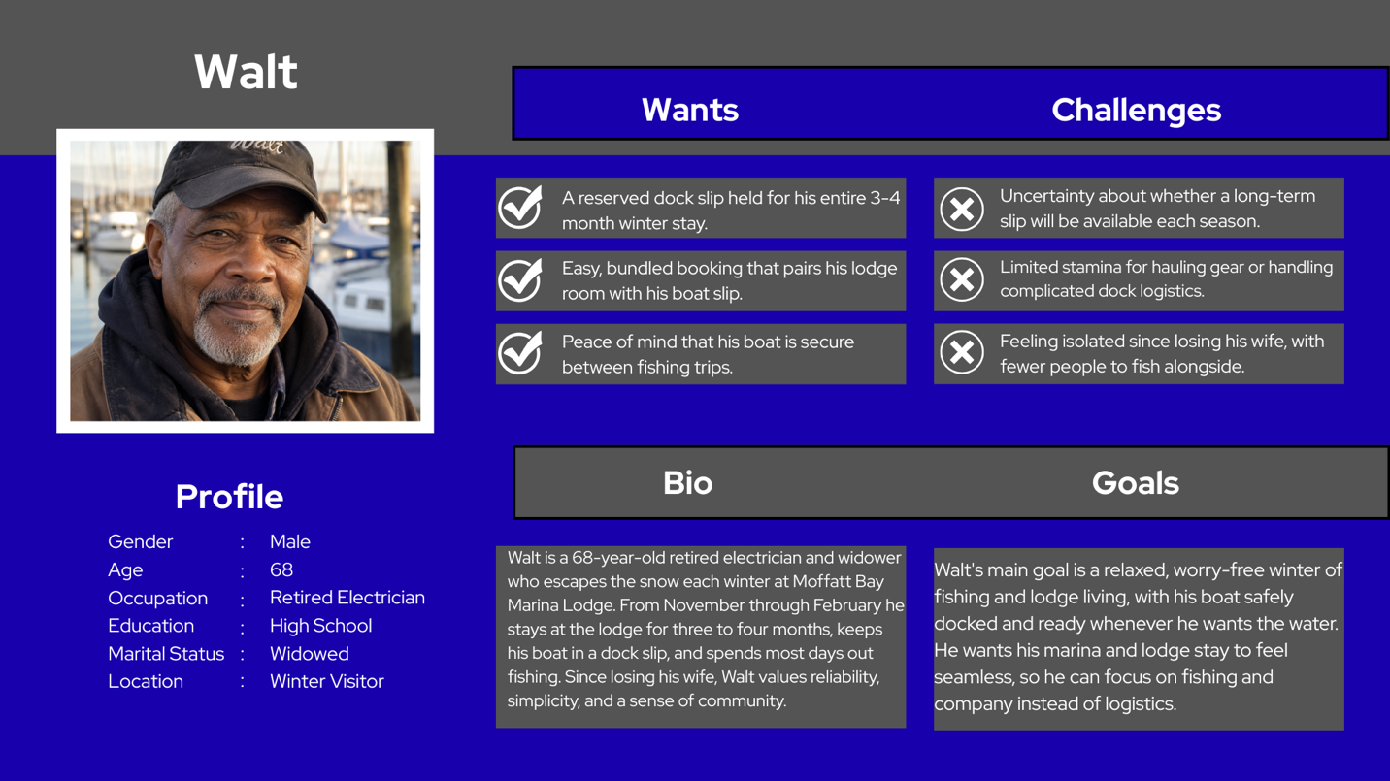

User Stories
- As a winter dock guest, I want to reserve a dock slip for a full 3–4-month block in one transaction, so I don’t have to re-book or risk losing my spot month to month.
- As a guest who is older, I would prefer to select a dock slip that is closer to the shore, so I don’t have to haul my equipment as far when I take it to and from the lodge.
- As a long-term slip holder, I would like clear, upfront pricing for a multi-month stay, including any seasonal or long-term discounts, so that I can budget for the winter without surprise fees.
- As a boat owner staying through long periods of time, I want information on what happens during inclement weather, such as procedures, safety, and insurance information.
- As a boat owner and slip holder, I would like the option to have marina staff check on my boat for me if I’m going to be gone for extended periods of time

